Response Video One- July 7, 2020

Question 1: In Laurence Maroney’s video, What is ML, he compares traditional programming with machine learning and argues that the main difference between the two is a reorientation of the rules, data and answers. According to Maroney, what is the difference between traditional programming and machine learning?

* Traditional Programming: One inputs rules and data in order to derive answers
* Machine Learning: One inputs data and answers in order to derive rules

Question 2: With the first basic script that Maroney used to predict a value output from the model he estimated (he initially started with 10 that predicted ~31. Modify the predict function to produce the output for the value 7. Do this twice and provide both answers. Are they the same? Are they different? Why is this so?

* Two answers provided: 22.00014 & 22.000448
* The two answers are slightly different due to the fact that neural networks deal with probabilities rather than certainties. Because it is a stochastic process, the answers will be very close but not often the same.

Question 3: Using the script you produced to predict housing price, take the provided six houses and train a neural net model that estimates the relationship between them. Based on this model, which of the six homes present a good deal? Which one is the worst deal? Justify your answer.

* By making a neural net model, we can estimate what each house should be priced based on bedroom number. Looking at the output of the code, we see that 160 Holly Point Rd, a house with three bedrooms selling for $97,000, is the best deal. Based on the model, we see that 760 New Point Comfort Hwy, a five bedroom house selling for $577,200, is the worst deal.
* 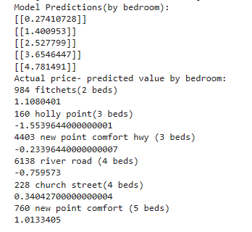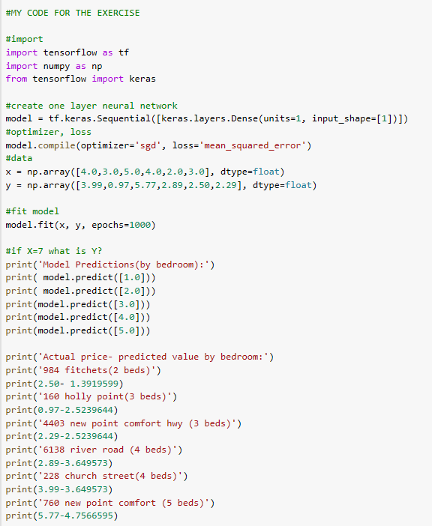This model could have been strengthened by using square footage instead of bedroom count in the input. Thus, it would account for other spaces and bathroom count.